Amortisation/Accrual of Charges in MD.DEAL
The charges so defined in MD.DEAL can also be either amortised or accrued over a period of time. These charges, whether to be accrued or amortised, and the period over which these are to be accrued or amortised, etc., are defined in FT.COMMISSION.TYPE.
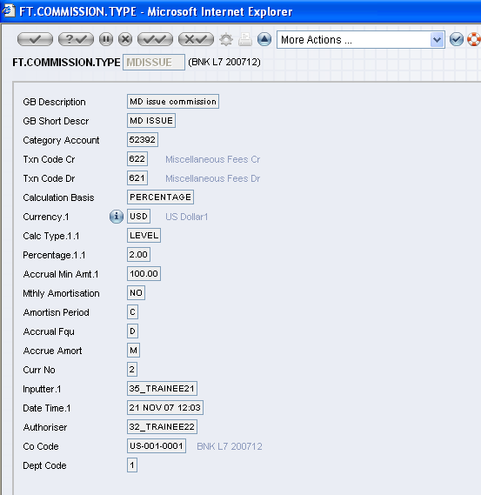
FT.COMMISSION.TYPE
If no values are defined in the above fields then the accrual of charge will not take place and P&L will be credited directly on the charge date.
When a charge where amortise or accrue is defined is attached to an MD contract, on authorisation the system creates a record in the EB.ACCRUAL application where all the details required by the core system to carry out the accrual process are updated. Further, Ids of all the EB.ACCRUAL records created for a contract are updated in a concat file called EB.ACCRUAL.CONCAT.
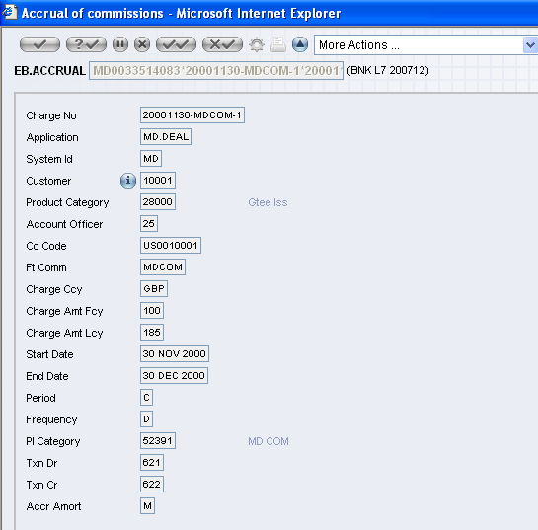
EB.ACCRUAL
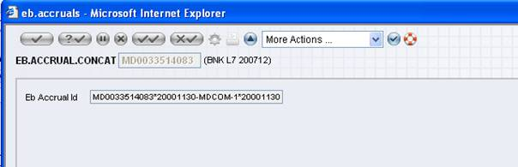
EB.ACCRUAL.CONCAT
The valid values that are accepted in the AMORTISN.PERIOD field in FT.COMMISSION.TYPE (FTC) that are defaulted in the field PERIOD in the EB.ACCRUAL record are "C" (Model Bank period), "R" (period between schedules), nM (number of months) and nA (number of years). The start date and end date of the amortisation or accrual depends on the value input in this field as detailed below:
Table 1: Monthly or Yearly period is defined in FTC
Charge Date | Accrual (A) or Amortisation (M) Processing | AMORTISN.PERIOD = M / A
Charge Date | Accrual (A) or Amortisation (M) Processing | Start Date | End Date
Value date | Amort Processing only | Charge Date (i.e., the Value date) | Date as per the number of months, or Model Bank date, whichever is earlier
Model Bank date | Accrual Processing only | Date as per the number of months, or Value Date, whichever is later | Charge Date (i.e., the Model Bank date)
Any date between Value date and Model Bank date | Accrual processing | Date as per the number of months, or Value Date, whichever is later | Charge Date
 | Amort processing | Charge Date | Date as per the number of months, or Model Bank date, whichever is earlier
Table 2: Model Bank Period (C) or Period between Schedules (R) is defined in FTC. However, as charges in MD are not linked to any schedule, "R" behaves as "C".
Charge Date | Accrual (A) or Amortisation (M) Processing | AMORTISN.PERIOD = R / C
Charge Date | Accrual (A) or Amortisation (M) Processing | Start Date | End Date
Value date | Amort Processing only | Charge Date (i.e., the Value date) | Model Bank Date
Model Bank date | Accrual Processing only | Value Date | Charge Date (i.e., the Model Bank date)
Any date between Value date and Model Bank date | Accrual processing | Value Date | Charge Date
Any date between Value date and Model Bank date | Amort processing | Charge Date | Model Bank Date
No accrual or amortisation of charge will take place if the amount of charge is less than or equal to the ACCRUAL.MIN.AMT in FT.COMMISSION.TYPE, and P&L will be credited directly.
If a charge where amortisation is defined is attached to MD, and the charge date is the Model Bank date of the contract, then no amortisation of charge will take place, and P&L will be credited directly on the charge date, i.e., Model Bank date. In the same way, if a charge where accrue is defined is attached to MD and the charge date is the value date of the contract, then no accrual of charge will take place, and P&L will be credited directly on the charge date, i.e., value date.
If the charge currency is different from the deal currency then no amortisation or accrual of charge will take place even if the same is defined, and P&L will be credited directly on the charge date.
During the tenure of the accrual of a charge, if the amount to be charged is amended in FT.COMMISSION.TYPE, there will be no impact on the amount of the charge that is being accrued unless the user revisits the MD contract and makes an amendment to the charge amount either by deleting the existing value or inputting a new value.
If a tax is attached to the charge no accrual will take place for the tax amount. On the charge date, the tax amount will be collected along with the charge amount, and the internal account defined for tax will be credited.
It is also possible to reverse the accrual posted up to yesterday, and raise a new accrual till the next working day by defining the PL categories for which the reversal of accrual should take place in the ACCR.REV.PARAM record.
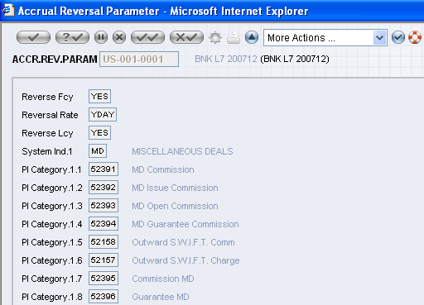
ACCR.REV.PARAM
The system can also amortise the charge, collected in a foreign currency, in the local currency by setting the field AMORT.IN.LOCAL to "YES" in ACCOUNT .PARAMETER. In such cases the CONTRACT.BAL.ID field in the EB.ACCRUAL record will be updated with Contract ID:"LOCAL", and a EB.CONTRACT.BALANCES record with Id as Contract ID:"LOCAL" will be created. However, charges where "A" (accrue) is defined cannot be accrued in local currency.
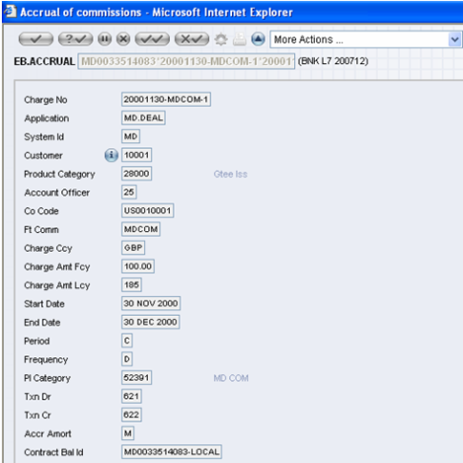
EB.ACCRUAL
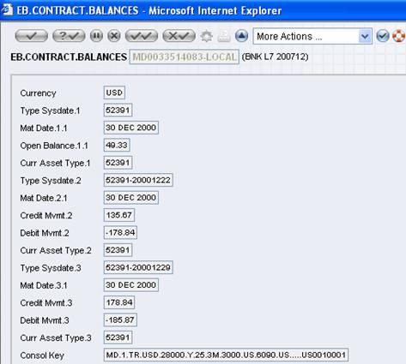
EB.CONTRACT.BALANCES

